**ABP News Case Study**

1. **Introduction**

ABP News Network (ANN)—one of the largest TV networks in India—operates five news channels in Indian languages such as Hindi, Marathi, Bengali, Punjabi, and Gujarati, and reaches out to more than 150 million TV audiences per week.

1. **Before Cloud**
2. **Challenges**

News in India can occur in a more dynamic, volatile, and unpredictable way compared to other international markets. This means spikes in traffic to digital and mobile news services can occur at any time of the day with minimal warning. A major breaking news story can increase traffic by three times, rising to six times for elections that may occur as often as once a year.

It was therefore extremely important for ANN to scale the technology infrastructure quickly to support these traffic spikes. Furthermore, similarly to international consumers, Indian audiences were increasingly consuming news through digital and mobile services, as well as through broadcast and print. Videos uploaded online were increasingly complementing broadcast and text-based news services. In 2013, ANN predicted extending its digital presence from a single website to a range of services could increase its page views from 150 million to over 500 million. The business had to sustain this growth cost-effectively while delivering the responsiveness and reliability that digital consumers demanded. “Considering all the factors in play, we wanted a robust, cost-optimized infrastructure that was reliable and highly scalable,” says Retesh Gondal, head of digital technology at ANN.

Unfortunately, ANN’ existing managed service provider technology infrastructure could not meet these challenges. The business’s agreement with this provider made scaling its website at short notice to support traffic spikes difficult and expensive. Furthermore, ANN could not gain the visibility to control and optimize its use of infrastructure resources.

The business also risked ceding competitive advantage to rival media companies by delivering new websites, mobile services, and other products to market in months rather than weeks. The limitations of the infrastructure meant editors would be forced to take up to seven minutes to upload a news video several times longer than a media business operating in a highly competitive marketplace could tolerate.

Ultimately, ANN risked not being able to deliver news quickly to meet viewer demands for immediacy and secure a strong position in the competitive digital news market in India. Furthermore, the business could not position itself to enter new geographic markets seamlessly and cost-effectively.

1. **After Cloud**
2. **Benefits**

* Cuts video uploading times from seven minutes to less than one minute
* Supported growth from 150 million to 500 million page views
* Scaled to support traffic spikes of up to six times during peak periods
* The company is running its services including websites, mobile apps, and a video content management system on AWS

1. **AWS Service Used**

* Amazon S3
* Amazon EC2
* Amazon Kinesis
* Amazon Lambda

1. **Conclusion**

**Buzzdial Case Study**

1. **Introduction**

Founded in 2013, Buzzdial builds technologies that enable publishers and broadcasters, as well as brands, to supplement television shows with a cross-screen digital experience that can be accessed on viewers’ computers, tablets and mobile phones, and integrated with the broadcast.

**For example**: Buzzdial delivered a “rate the debate” interface to smartphones, tablets, and computers that enabled viewers to express their sentiment during a United Kingdom leaders’ debate on network TV ahead of a general election.

1. **Before Cloud**

Buzzdial selected Amazon Web Services (AWS) as a cloud service provider that could meet its needs. “As we explored options during our establishment phase, AWS emerged as a frontrunner to host our services,” says Howard. “We found it extremely easy to use and massive in scale, which suited our plans to operate in Australia, Europe, the United States and other markets.” The fact AWS operated data centers around the world meant Buzzdial could provision infrastructure and deliver services from locations geographically close to broadcast events in a range of countries.

The business worked closely with AWS solution architects in New Zealand to determine the best architecture for its service. “The teams were extremely helpful in validating some of the ideas we had that made it to market. They also helped us reject options that simply weren’t going to work,” says Howard. To boost Buzzdial’s confidence, AWS shared stories about successful AWS customers, provided access to businesses that were undertaking similar projects, and demonstrated deep technical knowledge.

Buzzdial then developed the first stage of its service and created the supporting AWS architecture in four weeks. Initially the business created a monolithic web application that was not optimized for continuous development. As Buzzdial learned more about how AWS performed, its engineers opted to break the application up into a series of smaller, interoperating pieces. This process has enabled Buzzdial to pursue an agile software development process over the last 18 months, involving regular releases and continuous development.

Buzzdial’s application now runs in Amazon Elastic Compute Cloud (Amazon EC2) instances residing behind Elastic Load Balancing to distribute incoming traffic in such a way as to maximize fault tolerance and minimize latency. The application is distributed across discrete application programming interface, web delivery, caching, and database layers. Amazon Route 53 provides domain name services (DNS) that connect viewers with the required resources in AWS, while Amazon Relational Database Service (Amazon RDS) for MySQL provides a relational database engine to support the service. Caching is undertaken at the Amazon EC2 level to prevent the database infrastructure from being overloaded during periods of high demand. Buzzdial develops the application in house on Mac OS X machines and uses an Apache - Subversion - Beanstalk workflow to develop code for testing in the AWS infrastructure. The infrastructure is hosted in the US East (Northern Virginia) region.

Other services used include Amazon Simple Storage Service (Amazon S3) and Amazon CloudFront which provide a content delivery network for all static web resources including images, scripts, and style sheets. This significantly decreases load on the Amazon EC2 instances.

1. **Challenges**

* Buzzdial needed to launch onto an infrastructure that could keep costs low during the business’s establishment stage, and increase expenditure as more clients started using the service.
* The organization also wanted to pay for infrastructure on demand rather than invest in servers, storage, and networking resources that would remain underutilized except during traffic peaks for an hour or two during high-profile broadcast events.
* The infrastructure had to be highly available and scalable to support traffic during these events. In addition, the infrastructure also had to support Buzzdial’s plans to operate in several markets, and locate its services in data centers close to prospective clients and viewers to minimize latency that could disrupt the viewers’ second screen experience during television programs.

1. **After Cloud**
2. **Benefits**

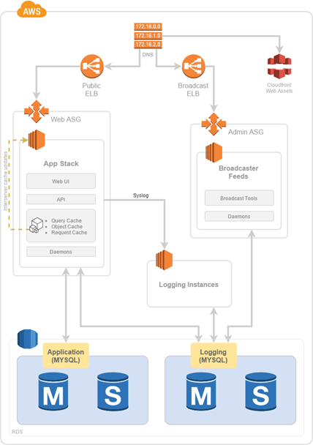

1. **AWS Service Used**

* Amazon S3
* Amazon EC2
* Elastic Load Balancing
* Amazon Route 53

1. **Conclusion**

**Classle Case Study**

1. **Introduction Classle**

* a cloud-based social learning platform that allows students to connect with other students as well as experts and professionals from academic, research institutes and industry.
* The goal of the company’s platform is to assist students pursuing higher education learn and develop skills in a manner unencumbered by socio-economic, location and resource barriers.
* a social enterprise, is currently focusing on rural regions of India where students struggle with resource limitations.

1. **Before Cloud**

Amazon Web Services (AWS) has been the foundation of Classle’s infrastructure since the company’s inception. Vaidya Nathan, Founder and CEO-Classle, explains that AWS allowed the company to begin operations six months ahead of schedule and more economically than had been anticipated. Classle is also impressed with the growing list of additional services offered by AWS, which the company has embraced to help further its own expansion.

Vaidya Nathan says, “The flexibility, reliability, and elasticity were the reasons for the initial decision to use AWS. Over the past two years, other services coming from AWS like Amazon Relational Database Service (Amazon RDS), Amazon CloudFront, Amazon CloudWatch, Elastic Load Balancing, and Amazon Route 53 confirm that the decision was the right one. As a startup, we have to worry about balancing scalability with cash preservation, and we get the best of both worlds with AWS. We see AWS as a strategic fit for our long-term business strategy.”

Classle uses Amazon Elastic Compute Cloud (Amazon EC2), with the Amazon Elastic Load Balancing (Amazon ELB), Auto Scaling, and Amazon Elastic Block Storage (Amazon EBS) features, to handle its application and analytics server needs. Amazon RDS acts as Classle’s data warehouse and transactional database.

Amazon Simple Storage Service (Amazon S3), with the Reduced Redundancy Storage (RRS) feature, serves the dual function of providing Classle’s content downloads and acting as an origin server for Amazon CloudFront. The company has established Amazon’s content delivery service Amazon CloudFront as an edge server for streaming files and delivering the learning platform’s most requested video downloads. Classle indicates that the origin and edge server relationship the company has created between Amazon S3 and Amazon CloudFront has allowed it to reduce its Webpage load times by 180 percent and reduce its total costs by eight percent and in the case of video streaming, it brought the time-to-market down to 2 days.

The company monitors its AWS infrastructure with Amazon CloudWatch and uses Amazon Simple Notification Service (Amazon SNS) to delivery system load alerts to its developers. Additionally, Classle routes its users to its websites with Amazon’s Domain Name System (DNS) service, Amazon Route 53.

1. **Challenges**
2. **After Cloud**
3. **Benefits**

Based on its success in India, Classle plans to eventually expand its social learning platform to the worldwide market. In the more immediate future, the company is planning a Software-as-a-Service (SaaS) offering of its platform, in addition to the Website-based version. As Classle works toward these new goals, it will be looking to incorporate additional services from AWS, such as Amazon Simple Email Service (Amazon SES) and AWS CloudFormation, which assists developers in combining AWS resources within the company’s infrastructure.

Vaidya Nathan says, “Adopting AWS has given our company a competitive advantage, both at tactical as well as strategic levels. Thanks to AWS, we are effectively competing with some large and strong players in the e-learning space. Adopting AWS has let us keep our focus on the business and assume that the infrastructure will be available to match the velocity and growth.”

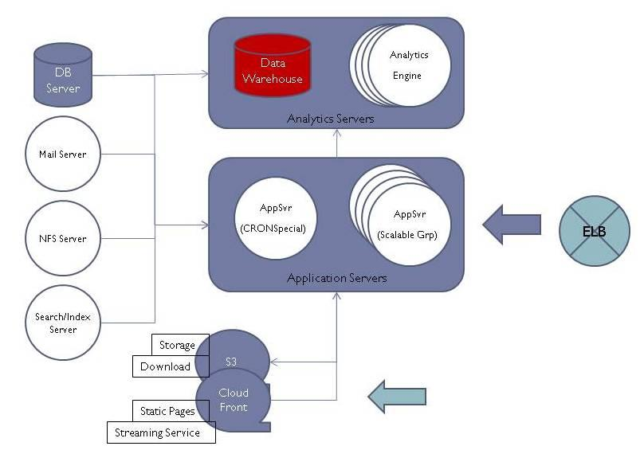

1. **AWS Services Used**

* Amazon RDS
* Amazon CloudFront
* Amazon CloudWatch
* Elastic Load Balancing

1. **Conclusion**

**LIFEPLATE Case Study**

1. **Introduction LIFEPLATE**

* A social-network website that connects people through common interests.
* Members create personalized taglines for use in keyword searches.
* Taglines are used in keyword searches, which enable members to quickly and easily find other people with the same interests, backgrounds, and opinions. Because the website uses a Google map interface, it is easy to connect with other members in the same geographic area.

1. **Before Cloud**

The website primarily uses PHP, SQL, and JavaScript as its programming languages. Additionally, LIFEPLAT uses available command line tools and PHP libraries to interface with the Amazon API. The AWS components of the website are Amazon Simple Storage Service (Amazon S3), Amazon CloudFront, Amazon Elastic Compute Cloud (Amazon EC2), Elastic Load Balancing, and Amazon Relational Database Service (Amazon RDS).

Although LIFEPLAT had some preliminary concerns regarding scalability and server responsiveness, Edward affirms that AWS has been extremely helpful in solving these issues. Amazon S3 and Amazon CloudFront deliver high-speed images to the site’s users while providing reliable and unlimited file storage. Because Amazon EC2 scales up or down according to usage, the auto-scaling feature of Amazon EC2 eliminates concerns about the Website handling peak-time operation. Elastic Load Balancing automatically distributes incoming application traffic so that processing is more efficient. With Amazon RDS, LIFEPLAT personnel can successfully manage the database in a scalable and responsive way.

1. **Challenges**

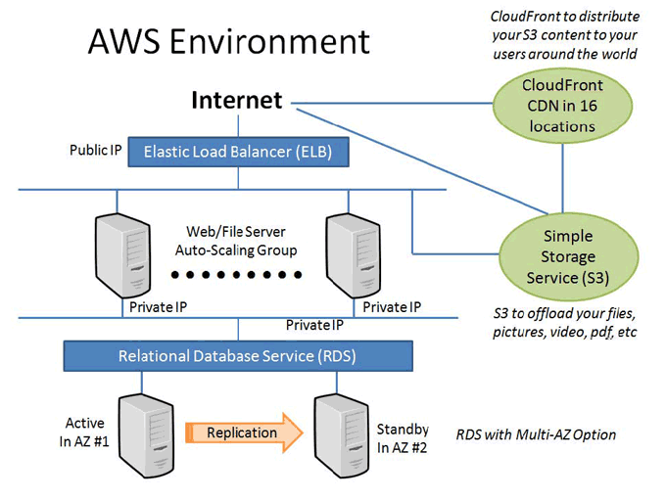When deciding to move the website to a cloud platform, LIFEPLAT considered several providers. After a great deal of research, LIFEPLAT determined that Amazon Web Services (AWS) offered the solution which best addressed the company’s needs while helping the company solve some key concerns related to scalability and server responsiveness. Edward Hsiao, CEO of LIFEPLAT, explains that “with AWS having an Asia-Pacific presence, it seemed only logical to use AWS, as our current target users are mostly in this area.” Another deciding factor was the ability to move the website to the cloud without extensive modification to the scripts and database structures. Although security was not initially a key issue for Lifeplat, Edward was extremely pleased to discover that the security measures of AWS were stringent enough to protect the website and its data.

1. **After Cloud**
2. **Benefits**
   * LIFEPLAT considers its decision to use the AWS solution a wise one.
   * Edward explains that the migration process was quite easy and painless, and said “AWS removes my future concerns as a Website developer and owner.
   * With AWS, I know my website is now able to withstand growth and attacks.”

* The AWS solution is so effective that LIFEPLAT is currently looking into the new features of Amazon RDS.

1. **AWS Services Used**

* Amazon EC2
* Amazon S3
* Amazon CloudFront
* Elastic Load Balancing
* Amazon RDS

1. **Conclusion**